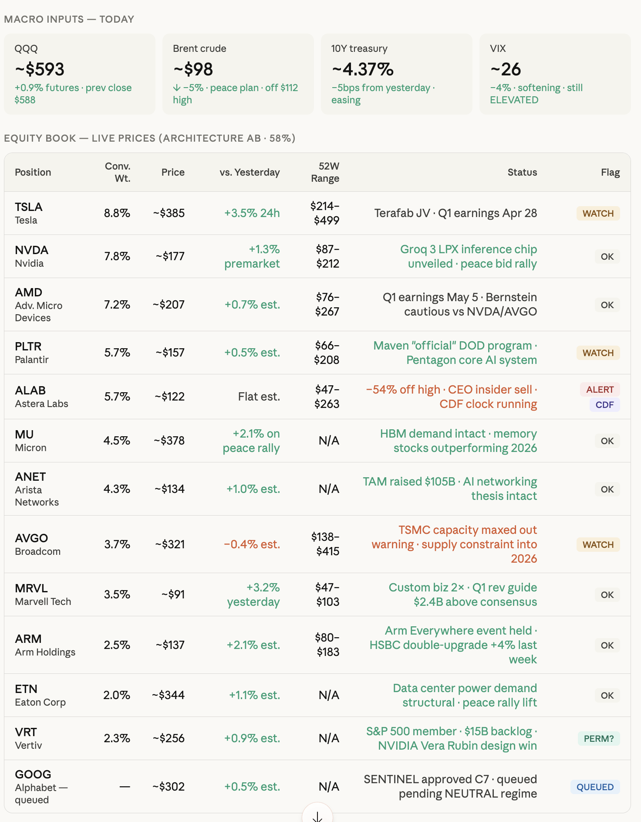
MACRO INPUTS TODAY
QQQ
-$593
Brent crude
-$98
10Y treasury
~4.37%
+0.9% futures. prev close $588
✓ -5% peace plan. off $112 high
-5bps from yesterday. easing
EQUITY BOOK - LIVE PRICES (ARCHITECTURE AB 58%)
VIX
~26
-4% softening. still ELEVATED
Position
Conv. Wt.
52W
Price
vs. Yesterday
Range
Status
Flag
TSLA Tesla
$214-
8.8% -$385
+3.5% 24h
Terafab JV Q1 earnings Apr 28
WATCH
$499
NVDA
+1.3%
$87-
7.8%
~$177
Nvidia
premarket
$212
Groq 3 LPX inference chip unveiled peace bid rally
OK
AMD
$76-
Adv. Micro
7.2%
~$207
+0.7% est.
$267
Q1 earnings May 5. Bernstein cautious vs NVDA/AVGO
OK
Devices
PLTR
$66-
5.7%
~$157
+0.5% est.
Palantir
$208
Maven "official" DOD program. Pentagon core Al system
WATCH
ALAB
$47-
5.7% ~$122
Flat est.
Astera Labs
$263
-54% off high. CEO insider sell. CDF clock running
ALERT
CDF
MU Micron
4.5% -$378
+2.1% on peace rally
N/A
HBM demand intact memory stocks outperforming 2026
OK
ANET
Arista
4.3%
~$134
+1.0% est.
N/A
TAM raised $105B. Al networking thesis intact
OK
Networks
AVGO Broadcom
$138-
3.7% ~$321
-0.4% est.
$415
TSMC capacity maxed out warning supply constraint into
WATCH
2026
MRVL
3.5%
~$91
Marvell Tech
+3.2% yesterday
$47-
$103
Custom biz 2x. Q1 rev guide $2.4B above consensus
OK
ARM
$80-
2.5%
-$137
+2.1% est.
Arm Holdings
$183
Arm Everywhere event held. HSBC double-upgrade +4% last week
OK
ETN
2.0%
~$344
+1.1% est.
N/A
Eaton Corp
Data center power demand structural peace rally lift
OK
VRT
2.3%
~$256
+0.9% est.
N/A
Vertiv
S&P 500 member $15B backlog. NVIDIA Vera Rubin design win
PERM?
GOOG
Alphabet -
~$302
+0.5% est.
N/A
SENTINEL approved C7 queued pending NEUTRAL regime
QUEUED
queued

